**JSP Product Details**

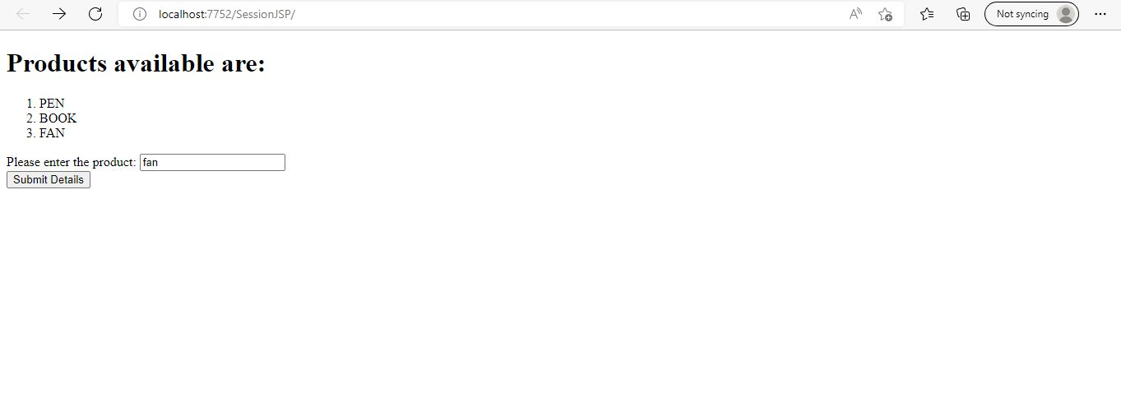

* This is the user interface where user can select the listed products to get the details of the products

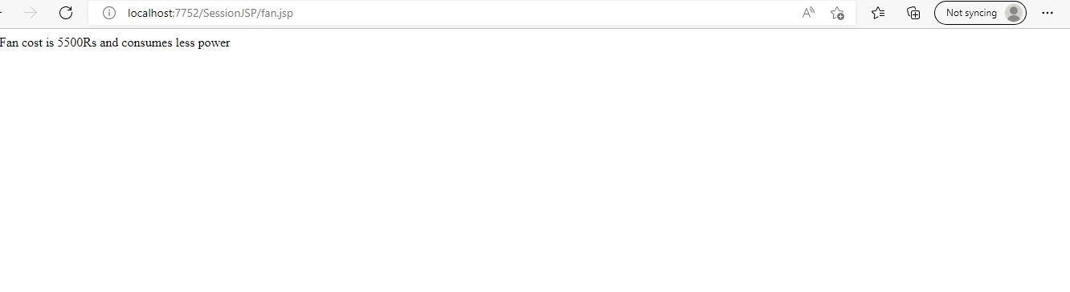

Fan details

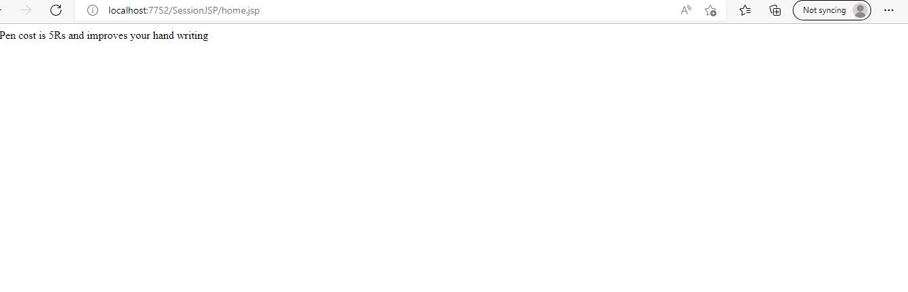

Details of Pen